**PRACTICAL – 12.2**

**AIM:**

Design an I-OS application representing a simple calculator.

**PROGRAM CODE:**

class ViewController: UIViewController {

@IBOutlet weak var Number1: UITextField!

@IBOutlet weak var Number2: UITextField!

@IBOutlet weak var labelanswer: UILabel!

@IBOutlet weak var btnadd: UIButton!

@IBOutlet weak var btnsubtract: UIButton!

@IBOutlet weak var btnmultiply: UIButton!

@IBOutlet weak var btndivide: UIButton!

override func viewDidLoad() {

super.viewDidLoad()

// Do any additional setup after loading the view.

}

@IBAction func btnaddclick(_ sender: Any) {

let a:String! = Number1.text

let b:String! = Number2.text

let a1:Int! = Int(a)

let a2:Int! = Int(b)

let c = a1 + a2

labelanswer.text = "Answer is \(c)"

print("add")

}

@IBAction func btnsubtractclick(_ sender: Any) {

let a:String! = Number1.text

let b:String! = Number2.text

let a1:Int! = Int(a)

let a2:Int! = Int(b)

let c = a1 - a2

labelanswer.text = "Answer is \(c)"

print("subtract")

}

@IBAction func btnmultiplyclick(_ sender: Any) {

let a:String! = Number1.text

let b:String! = Number2.text

let a1:Int! = Int(a)

let a2:Int! = Int(b)

let c = a1 * a2

labelanswer.text = "Answer is \(c)"

print("multiply")

}

@IBAction func btndivideclick(_ sender: Any) {

let a:String! = Number1.text

let b:String! = Number2.text

let a1:Float! = Float(a)

let a2:Float! = Float(b)

let c = a1 / a2

labelanswer.text = "Answer is \(c)"

print("divide")

}

}

**OUTPUT:**

**Addition**:

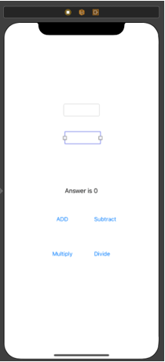 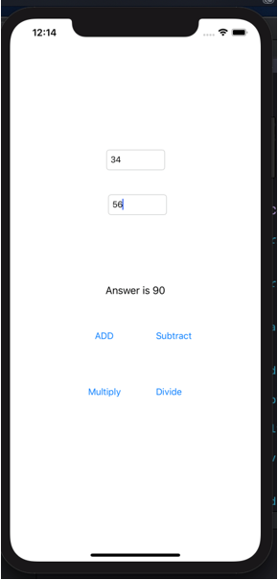

**Subtraction:**

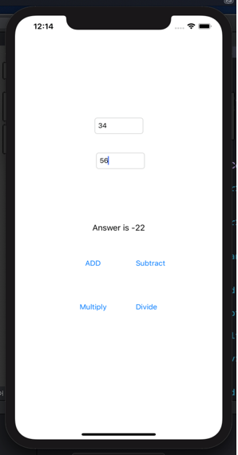

**MULTIPLICATION:**

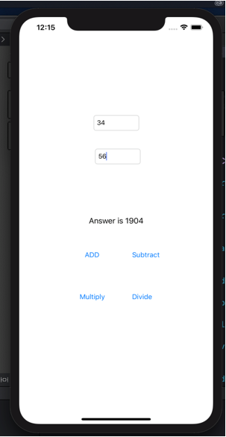

**Division**:

